|  |  |  |  |  |  |
| --- | --- | --- | --- | --- | --- |
| Date | 28-Nov-22 | | | Tester Name | Richard Belanger |
| Environment | Penfax - Test | | | Login used | TEST2 |
| Operating System | Windows | Version: | Update: | | |
| Software Used | Edge | Version: | Update: | | |
| Not Applicable | Version: | Update: | | |
| Release version | 22.4.1 | | | | |
| Title | M5.03 Vested Casual member with small benefit | | | | |
| Test Type | Regression | | | | |
| Test Scenario | Member will be Terminated and payment produced with correct taxes withheld | | | | |
|  |  | | | | |
| Expected Results | Member will be Terminated and payment produced with correct taxes withheld | | | | |
| Pass/Fail | Pass | | | JIRA# | N/A |

Describe your steps with screenshots:

Member is Vested

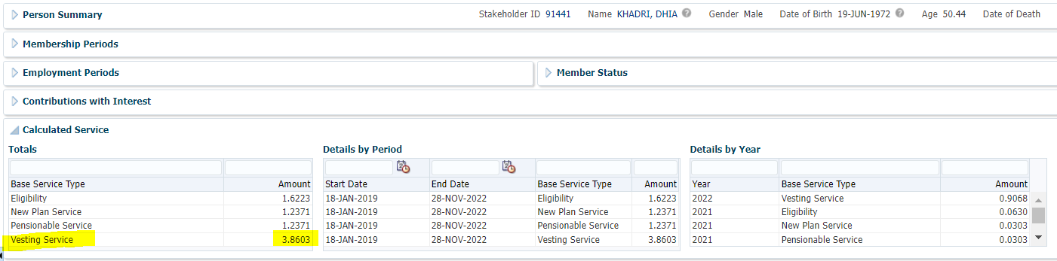

Member is a Casual Employee> Terminate Member

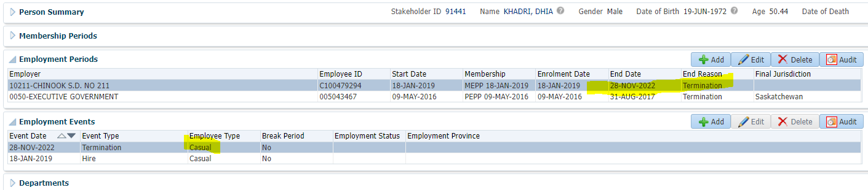

Member Profile>Benefit Calculation

Calculate

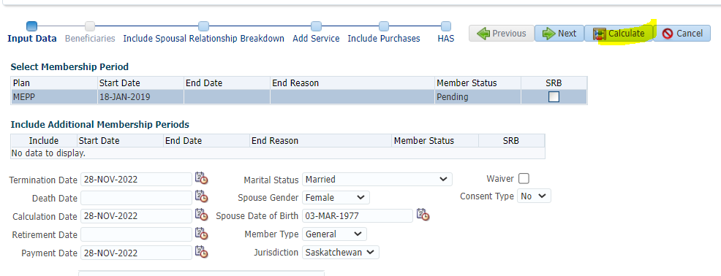

Member has a Small Benefit, not Locked-In>Processed

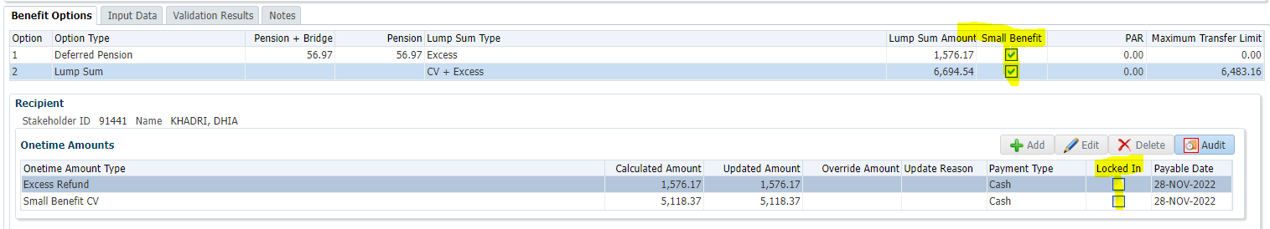

To Benefit Selection> Next

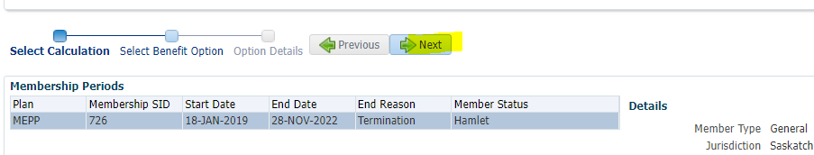

Choose Lump Sum line Add Payment Date>Next

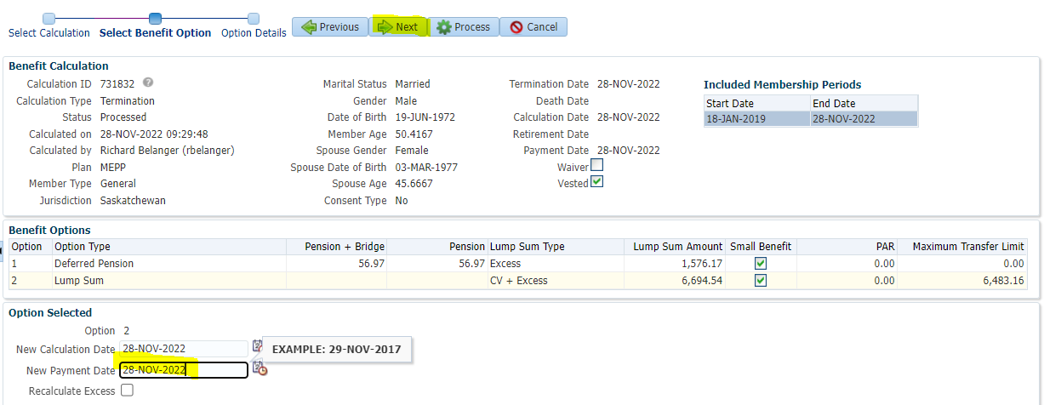

Send EXCESS Refund to Cash; Send Small Benefit CV to RRSP>Process

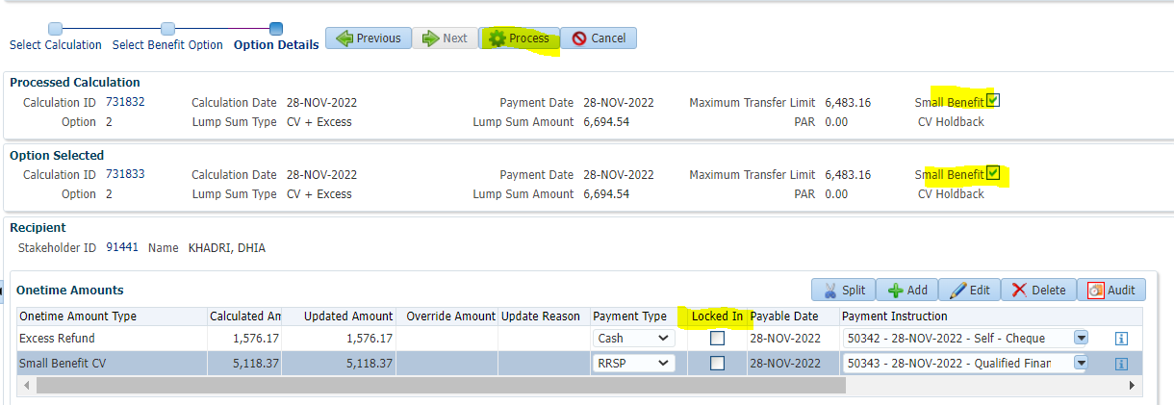

To Benefit Recipient

Submit the Payment lines for Approval>Approve

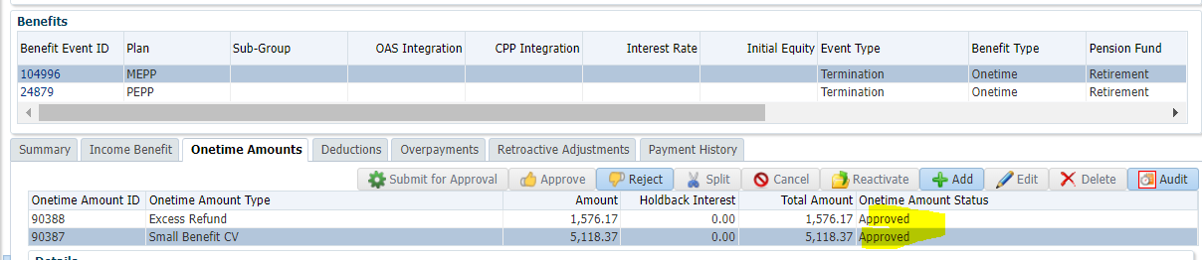

To Summary>Authorize

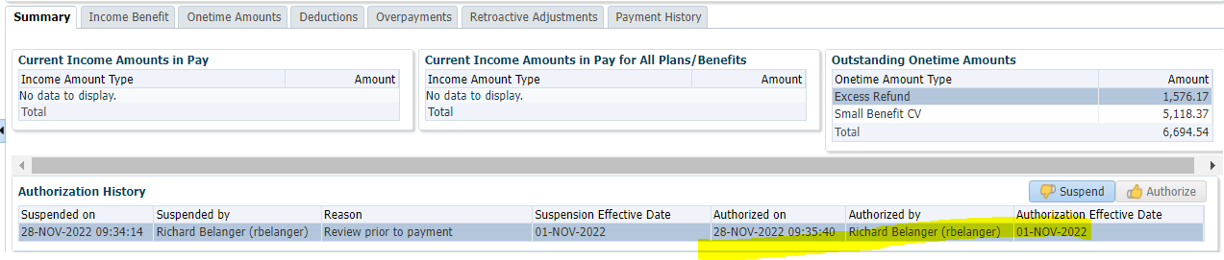

Payment produced via PENFAX Payment Production

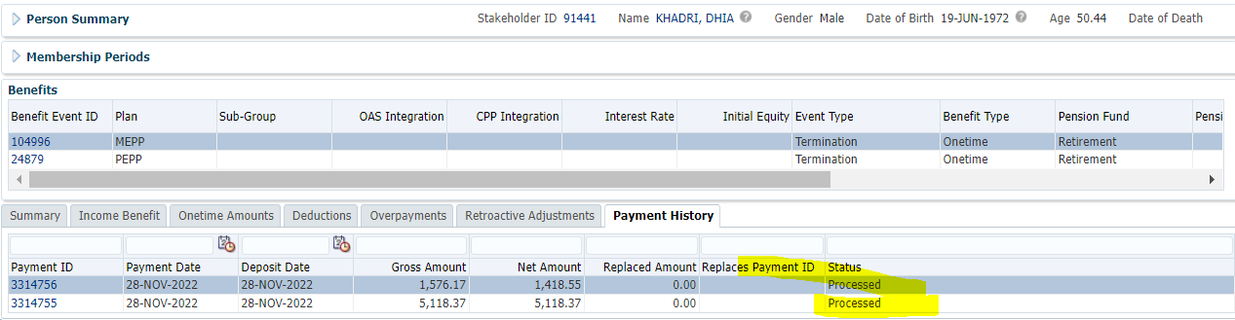

Tax Rates

0.00-4,999.99 = 10%

5,000.00- 14,999.99 = 20%

15,000.00+ = 30%

Excess Refund amount = 1,576.17; subject to 10% Tax;

1,576.17 x 10% = 157.62; 1,576.17 -157.62 = **$1,418.55**

RRSP not subject to Tax; **$5,118.37**